**SRM INSTITUTE OF SCIENCE AND TECHNOLOGY**

**Department of Electronics and Communication Engineering**

**Laboratory Report Cover Sheet**

**18ECC303J – COMPUTER COMMUNICATION NETWORKS**

### EVEN SEM 2022-23

Name :

Section :

Venue :

Experiment title : Simulation of CSMA/CD protocol and to study its

performance

|  |  |  |
| --- | --- | --- |
| **PARTICULARS** | **MAX MARKS** | **MARKS OBTAINED** |
| Pre lab & Post lab | 10 |  |
| Lab performance | 15 |  |
| Record | 05 |  |
| Viva | 10 |  |
| Total | **40** |  |

**Report Verification**

Staff Name:

Signature with date:

**1. Simulation of CSMA/CD protocol and to study its performance**

* 1. **Introduction**:

The purpose of this experiment is to understand the concept of Listen-while-transmit to improve efficiency. In this lab, you will be able to implement the CSMA/CD protocol for packet communication between a number of nodes connected to a common bus.

* 1. **Hardware Requirement**
* 3PCs with NIU card
* Network Emulation Unit
* Jumper Cables
  1. **Background**

***C****arrier* ***S****ense* ***M****ultiple* ***A****ccess /* ***C****ollision* ***D****etection,* a set of rules determining how [network](http://www.webopedia.com/TERM/C/network.htm) [devices](http://www.webopedia.com/TERM/C/device.htm) respond when two devices attempt to use a [data channel](http://www.webopedia.com/TERM/C/channel.htm) simultaneously (called a *collision*). Standard [Ethernet](http://www.webopedia.com/TERM/C/Ethernet.htm) networks use CSMA/CD to physically monitor the traffic on the line at participating stations. To translate this into Ethernet terms, each interface must wait until there is no signal on the channel, then it can begin transmitting. If some other interface is transmitting there will be a signal on the channel, which is called carrier. All other interfaces must wait until carrier ceases before trying to transmit, and this process is called Carrier Sense.

If no transmission is taking place at the time, the particular station can transmit. If two stations attempt to transmit simultaneously, this causes a collision, which is detected by all participating stations. After a random time interval, the stations that collided attempt to transmit again. If another collision occurs, the time intervals from which the random waiting time is selected are increased step by step. This is known as exponential back off.

**1.4 Pre lab questions**

1. Define network topology and list the types with the advantages and disadvantages.
2. Which media access method is used in Ethernet?
3. Which OSI Layer includes the CSMA/CD mechanism?
4. How is the collision occurrence intimated to other nodes in a network?
5. Define throughput**.**
   1. **Procedure:** 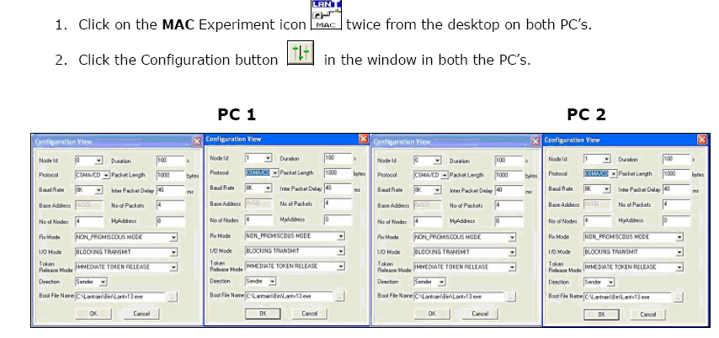

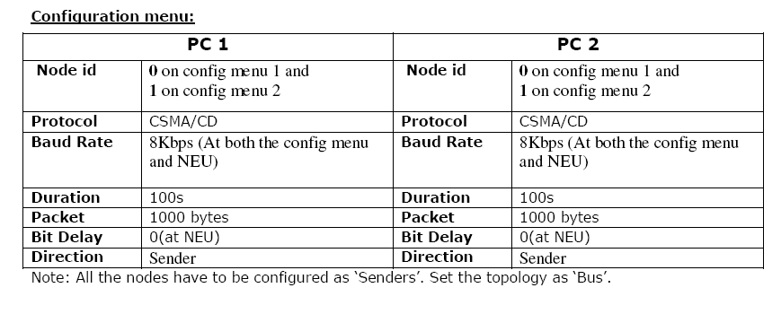

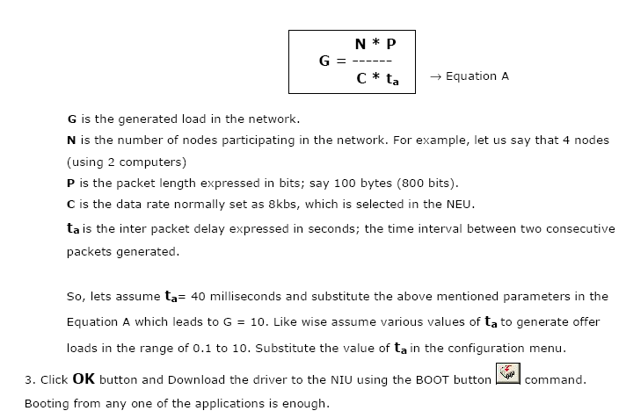

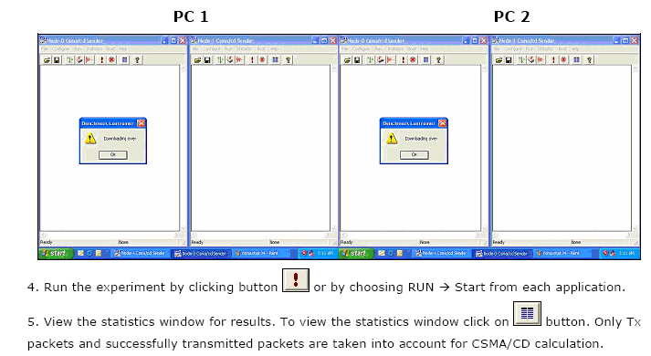

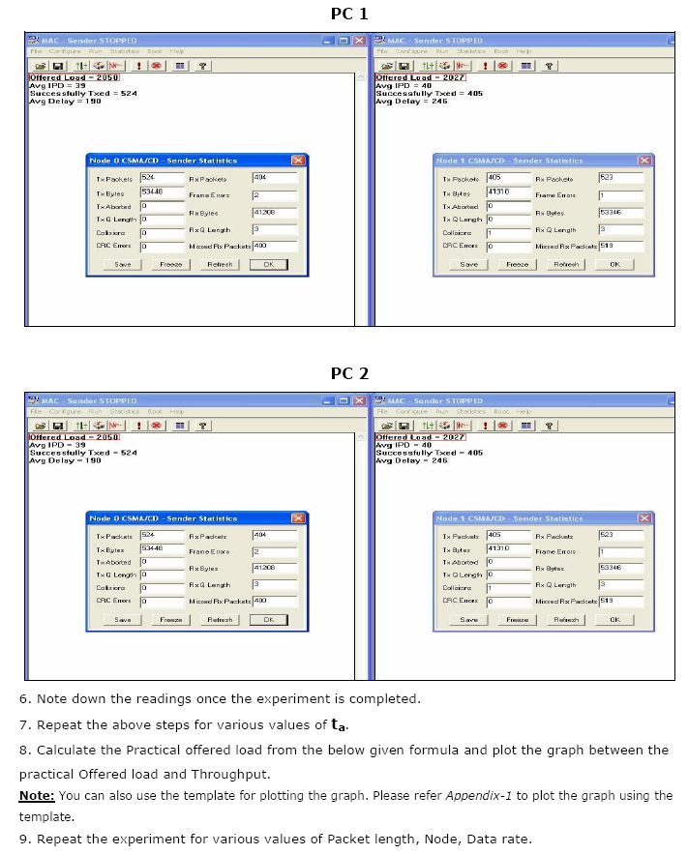

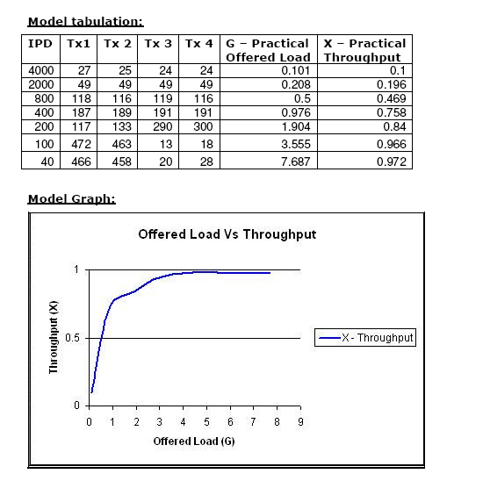

* 1. **Post lab questions:**

1. Calculate the throughput for a network with bandwidth 10 Mbps which can pass at an average of 12,000 frames /min each carrying 10,000 bits.
2. What are the drawbacks of CSMA/CD protocol?
3. Can a node transmit packets during back-off period? Why?
4. How to overcome the drawbacks of CSMA/CD?

**RESULT**